

|  |
| --- |
| ITECH3208 – Project 1  Sprint – 2 Team Artefacts Submitted to : Nityansh Rattan |
| |  |  |  | | --- | --- | --- | | Group – 1 Harmanpreet Singh Bedi 30410228 Sahejdeep Singh 30 Devansh Mahajan 30 Aakash 30 | 10/14/24 |  | |

Table of Contents

Introduction to Team 3

Complete Product Backlog (Sprint 1 + Sprint 2) 3

Epic 1 : Requirement Gathering and Specifications 3

Epic 2 : Design Mock-ups and Prototypes 4

Epic 3 : Develop Front-End Features 6

Epic 4 : Back-End Development and Integration 7

Epic 5 : Quality Assurance and Testing 8

Revised Product Backlog (Sprint 1 + Sprint 2) 9

Epic 1 : Requirement Gathering and Specifications 9

Epic 2 : Design Mock-ups and Prototypes 10

Evidences toward final product / deliverable 12

# Introduction to Team

This section will cover the names of the team members and their roles with description towards completing sprint 1 and sprint 2.

|  |  |  |  |
| --- | --- | --- | --- |
| **ID** | **Team Member’s Name** | **Roles** | **Description** |
| 30410228 | Harmanpreet Singh Bedi | * Product Owner * UX Designer | * Reviews and approves mock-ups and prototypes to ensure the design meets project goals before development starts. * Creates mock-ups and prototypes based on client feedback and new requirements, ensuring that the designs are user-friendly and visually coherent. |
| 30 | Sahejdeep Singh | * UX Designer | * Creates mock-ups and prototypes based on client feedback and new requirements, ensuring that the designs are user-friendly and visually coherent. |
| 30 | Devansh Mahajan | * Project Manager | * Documents new requirements, updates the product roadmap, and ensures that feedback and changes are communicated to the team. |
| 30 | Aakash | * Front – End Developer | * Implements front-end pages based on approved designs, ensuring responsiveness across devices and integration with back-end systems. |

# Complete Product Backlog (Sprint 1 + Sprint 2)

## Epic 1 : Requirement Gathering and Specifications

This epic focuses on collecting client feedback and refining requirements based on insights gained from the first sprint review.

User Stories :

1. As a client, I want to provide feedback on the product's first sprint so that I can ensure the final product meets my expectations.
   * Priority Level : High
   * Value : Ensures alignment with client expectations and minimizes the risk of rework.
   * Effort : 3 story points
   * Conditions of Satisfaction :

* Client feedback is documented in a shared document.
* All team members can view and discuss the feedback.
  + Test Cases :
* Verify that feedback is documented correctly.
* Check that team members can access feedback.

1. As a project manager, I want to document new requirements after client feedback so that we can refine the product roadmap for future sprints.
   * Priority Level : High
   * Value : Enhances project transparency and ensures that the team is aligned on priorities.
   * Effort : 5 story points
   * Conditions of Satisfaction :

* New requirements are documented in Jira.
* Requirements are categorized by priority.
  + Test Cases :
* Verify that the new requirements are correctly recorded in the project management tool.

## Epic 2 : Design Mock-ups and Prototypes

This epic involves the design process, including creating mock-ups and interactive prototypes based on updated requirements.

User Stories :

1. As a UX designer, I want to create mock-ups for the new requirements so that the development team has a visual reference during implementation.
   * Priority Level : High
   * Value : Facilitates a clear understanding of design intent and improves communication within the team.
   * Effort : 5 story points
   * Conditions of Satisfaction :

* Mock-ups are created for all new features.
* Mock-ups are reviewed and approved by the product owner.
  + Test Cases :
* Verify that all mock-ups are linked to user stories in Jira.

1. As a product owner, I want to review and approve the new mock-ups before development starts so that we can ensure the designs align with project goals.
   * Priority Level : High
   * Value : Reduces the risk of costly changes later in the development process.
   * Effort : 3 story points
   * Conditions of Satisfaction :

* Mock-ups are presented in a review meeting.
* Feedback is documented and addressed.
  + Test Cases :
* Verify that feedback from the review is incorporated into the mock-ups.

1. As a client, I want to review updated mock-ups and prototype so that I can confirm that the product direction aligns with my expectations.
   * Priority Level : High
   * Value : Ensures client satisfaction by validating that the product aligns with their vision.
   * Effort : 4 story points
   * Conditions of Satisfaction :

* Prototypes are interactive and showcase key features.
* Client feedback is collected and documented.
  + Test Cases :
* Verify that the prototype functions as intended during the client review.

1. As a UI/UX designer, I want to create interactive prototype based on the previously created and approved mock-ups so that we can simulate user interactions and gather feedback before development.
   * Priority Level : High
   * Value : Improves usability and ensures a better user experience by testing designs early.
   * Effort : 6 story points
   * Conditions of Satisfaction :

* Interactive prototype is created using design tools (e.g., Figma, Adobe XD).
* Feedback sessions are held to gather insights.
  + Test Cases :
* Verify that interactions work as expected in the prototype.

## Epic 3 : Develop Front-End Features

This epic focuses on implementing the front-end designs into functional web pages.

User Stories :

1. As a frontend developer, I want to implement the front-end pages based on the approved mock-ups so that users have a usable interface.
   * Priority Level : Moderate (For current sprint)
   * Value : Transforms design concepts into a functional product for user interaction.
   * Effort : 8 story points
   * Conditions of Satisfaction :

* All front-end pages match the approved mock-ups.
* Functionality is tested across all supported browsers.
  + Test Cases :
* Verify that the implemented pages render correctly in all supported browsers and shows responsiveness.

1. As a user, I want the front-end pages to be responsive so that I can access the application seamlessly from any device.
   * Priority Level : Moderate (For current sprint)
   * Value : Enhances accessibility and improves user satisfaction by providing a consistent experience across devices.
   * Effort : 5 story points
   * Conditions of Satisfaction :

* Pages pass responsiveness testing on various devices (mobile, tablet, desktop).
  + Test Cases :
* Verify that the layout adjusts correctly on different screen sizes.

1. As a client, I want the front-end to accurately reflect the updated designs so that it meets the look and feel I approved.
   * Priority Level : Moderate (For current sprint)
   * Value : Ensures client satisfaction with the final product's appearance.
   * Effort : 3 story points
   * Conditions of Satisfaction :

* The client has the opportunity to review the front-end before deployment.
  + Test Cases :
* Verify that all design elements match the approved designs.

1. As a tester, I want to review the front-end pages for usability and functionality so that I can identify any issues before the product launch.
   * Priority Level : Moderate (For current sprint)
   * Value : Ensures the product is user-friendly and meets quality standards.
   * Effort : 4 story points
   * Conditions of Satisfaction :

* A comprehensive testing checklist is created.
* All identified issues are documented and addressed.
  + Test Cases :
* Verify that the usability testing results are recorded and actioned.

## Epic 4 : Back-End Development and Integration

This epic includes the development of the backend architecture, database setup, and integration with the front-end to create a fully dynamic website.

User Stories :

1. As a backend developer, I want to create the database schema so that the application has a structured way to store data.
   * Priority Level : Low (For current sprint)
   * Value : Ensures data integrity and organization for effective data management.
   * Effort : 8 story points
   * Conditions of Satisfaction :

* Database schema is reviewed and approved by the development team.
* Schema is implemented in the development environment.
  + Test Cases :
* Verify that the database schema supports all required data fields.

1. As a backend developer, I want to set up a local server environment so that the application can be tested before deployment.
   * Priority Level : Low (For current sprint)
   * Value : Allows for real-time testing and debugging of the application.
   * Effort : 5 story points
   * Conditions of Satisfaction :

* Local server is configured to mirror production settings (local server like XAMPP).
  + Test Cases :
* Verify that the application runs without errors on the local server.

1. As a frontend developer, I want to integrate the front-end with the back-end so that the website is fully dynamic and responsive to user actions.
   * Priority Level : Low (For current sprint)
   * Value : Provides a seamless user experience and ensures that users can interact with live data.
   * Effort : 8 story points
   * Conditions of Satisfaction :

* Front-end and back-end are successfully integrated.
* Data flow between the front-end and back-end is tested and documented.
  + Test Cases :
* Verify that user actions on the front-end reflect changes in the back-end data as well as it is also reflected back on the front-end.

## Epic 5 : Quality Assurance and Testing

This epic covers all testing activities to ensure the product meets the required quality standards.

User Stories :

1. As a QA tester, I want to conduct comprehensive testing on the newly implemented front-end features so that I can ensure they function correctly.
   * Priority Level : Low (For current sprint)
   * Value : Validates that the product meets functional requirements and provides a good user experience.
   * Effort : 6 story points
   * Conditions of Satisfaction :

* All new features are tested against the acceptance criteria.
* Bugs are logged in the issue tracking system.
  + Test Cases :
* Verify that all test cases are executed and results documented.

1. As a QA engineer, I want to perform usability testing on the prototypes and front-end features so that we can ensure a smooth user experience.
   * Priority Level : Low (For current sprint)
   * Value : Identifies usability issues before deployment, enhancing user satisfaction.
   * Effort : 5 story points
   * Conditions of Satisfaction :

* Usability testing results are compiled and reviewed.
  + Test Cases :
* Verify that user feedback is collected and analyzed for improvement.

1. As a developer, I want to fix any bugs identified during testing so that the product is stable and ready for deployment.
   * Priority Level : Low (For current sprint)
   * Value : Ensures a high-quality final product, reducing the likelihood of post-launch issues.
   * Effort : 5 story points
   * Conditions of Satisfaction :

* All identified bugs are addressed and retested.
  + Test Cases :
* Verify that all previously identified bugs are resolved.

# Revised Product Backlog (Sprint 1 + Sprint 2)

This section will cover the revised and completed Product Backlog during the completion of sprint 1 and sprint 2.

## Epic 1 : Requirement Gathering and Specifications

This epic focuses on collecting client feedback and refining requirements based on insights gained from the first sprint review.

User Stories :

1. As a client, I want to provide feedback on the product's first sprint so that I can ensure the final product meets my expectations.
   * Priority Level : High
   * Value : Ensures alignment with client expectations and minimizes the risk of rework.
   * Effort : 3 story points
   * Conditions of Satisfaction :

* Client feedback is documented in a shared document.
* All team members can view and discuss the feedback.
  + Test Cases :
* Verify that feedback is documented correctly.
* Check that team members can access feedback.

1. As a project manager, I want to document new requirements after client feedback so that we can refine the product roadmap for future sprints.
   * Priority Level : High
   * Value : Enhances project transparency and ensures that the team is aligned on priorities.
   * Effort : 5 story points
   * Conditions of Satisfaction :

* New requirements are documented in Jira.
* Requirements are categorized by priority.
  + Test Cases :
* Verify that the new requirements are correctly recorded in the project management tool.

## Epic 2 : Design Mock-ups and Prototypes

This epic involves the design process, including creating mock-ups and interactive prototypes based on updated requirements.

User Stories :

1. As a UX designer, I want to create mock-ups for the new requirements so that the development team has a visual reference during implementation.
   * Priority Level : High
   * Value : Facilitates a clear understanding of design intent and improves communication within the team.
   * Effort : 5 story points
   * Conditions of Satisfaction :

* Mock-ups are created for all new features.
* Mock-ups are reviewed and approved by the product owner.
  + Test Cases :
* Verify that all mock-ups are linked to user stories in Jira.

1. As a product owner, I want to review and approve the new mock-ups before development starts so that we can ensure the designs align with project goals.
   * Priority Level : High
   * Value : Reduces the risk of costly changes later in the development process.
   * Effort : 3 story points
   * Conditions of Satisfaction :

* Mock-ups are presented in a review meeting.
* Feedback is documented and addressed.
  + Test Cases :
* Verify that feedback from the review is incorporated into the mock-ups.

1. As a client, I want to review updated mock-ups and prototype so that I can confirm that the product direction aligns with my expectations.
   * Priority Level : High
   * Value : Ensures client satisfaction by validating that the product aligns with their vision.
   * Effort : 4 story points
   * Conditions of Satisfaction :

* Prototypes are interactive and showcase key features.
* Client feedback is collected and documented.
  + Test Cases :
* Verify that the prototype functions as intended during the client review.

1. As a UI/UX designer, I want to create interactive prototype based on the previously created and approved mock-ups so that we can simulate user interactions and gather feedback before development.
   * Priority Level : High
   * Value : Improves usability and ensures a better user experience by testing designs early.
   * Effort : 6 story points
   * Conditions of Satisfaction :

* Interactive prototype is created using design tools (e.g., Figma, Adobe XD).
* Feedback sessions are held to gather insights.
  + Test Cases :
* Verify that interactions work as expected in the prototype.

# Evidences toward final product / deliverables

1. All the meeting screenshots (with the team members and with the client).

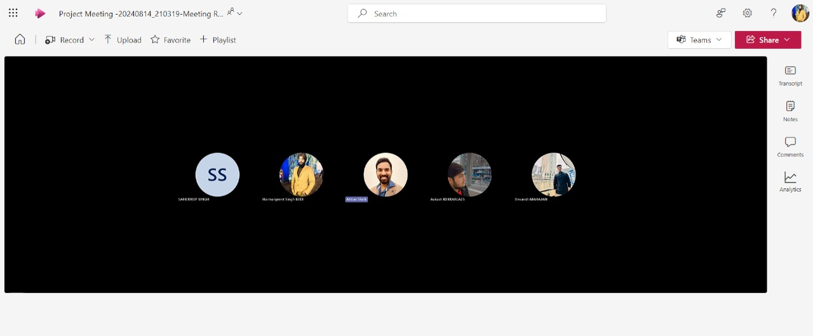

Figure 1. Client feedback meeting on Project Scope

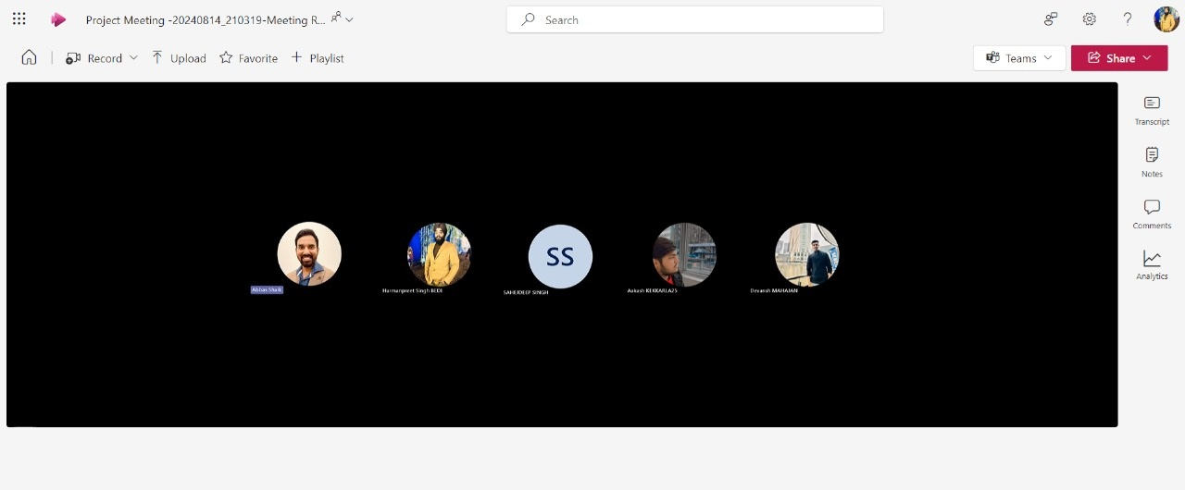

Figure 2. Client feedback meeting on Sprint 1 deliverables

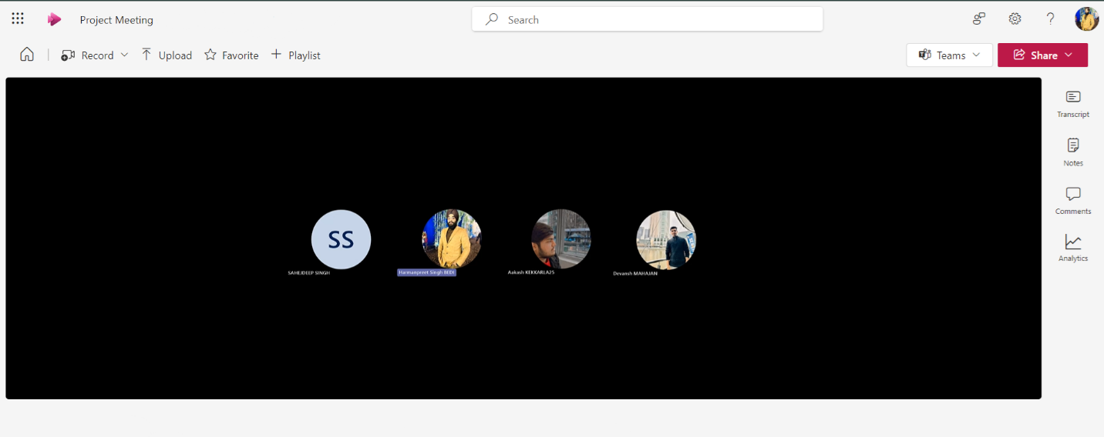

Figure 3. Team retrospective meeting at the end of Sprint 1

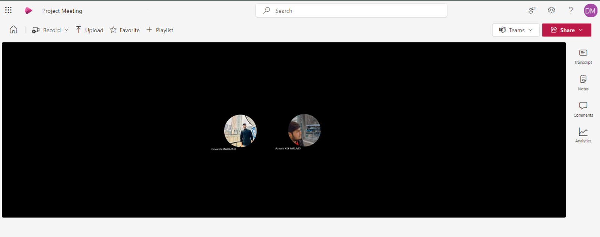

Figure 4. Team members meeting to discuss any feedback given by client on Sprint 1 deliverables

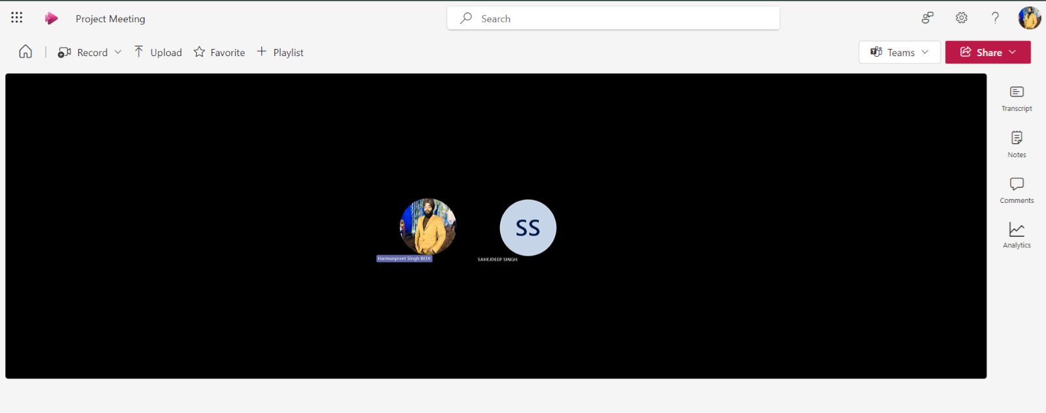

Figure 5. Team members meeting to discuss next mock-ups and prototype based on client’s feedback

1. 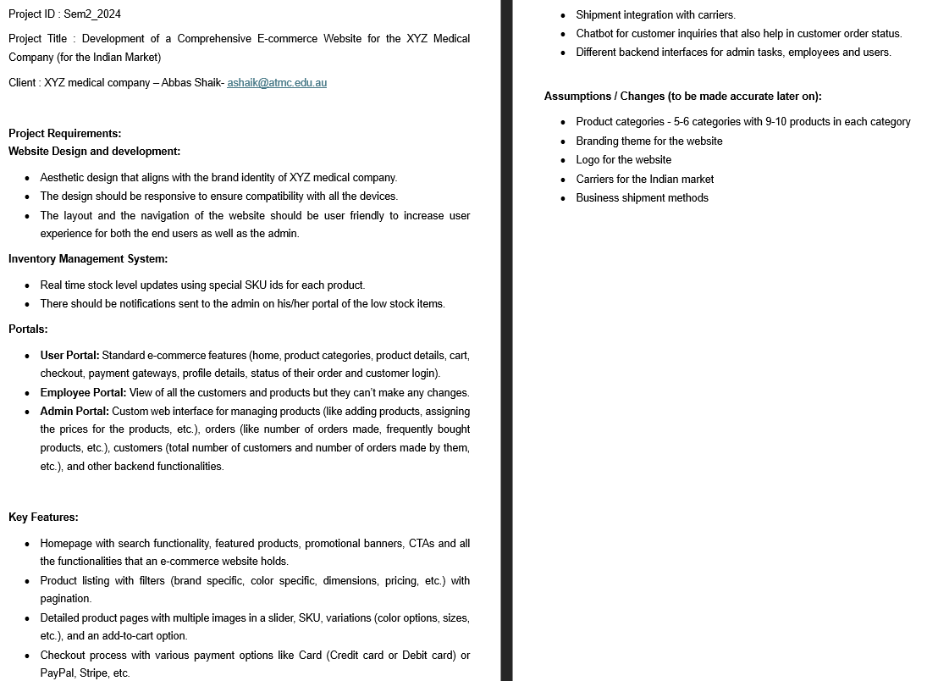Finalised Project Scope

Figure 6. Finalized Project Scope

1. Jira Board screenshots for both the sprints indicating starting of sprint and specified user stories, and completion of the sprint.

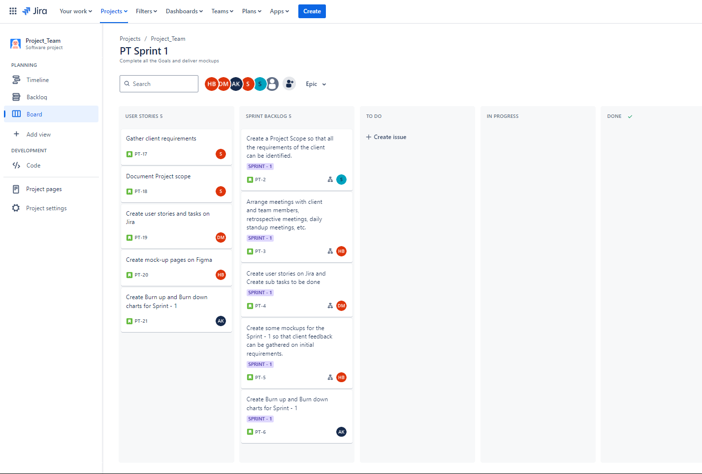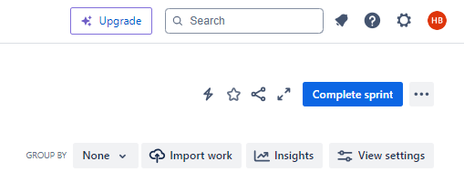

Figure 7. Sprint 1 Product backlog

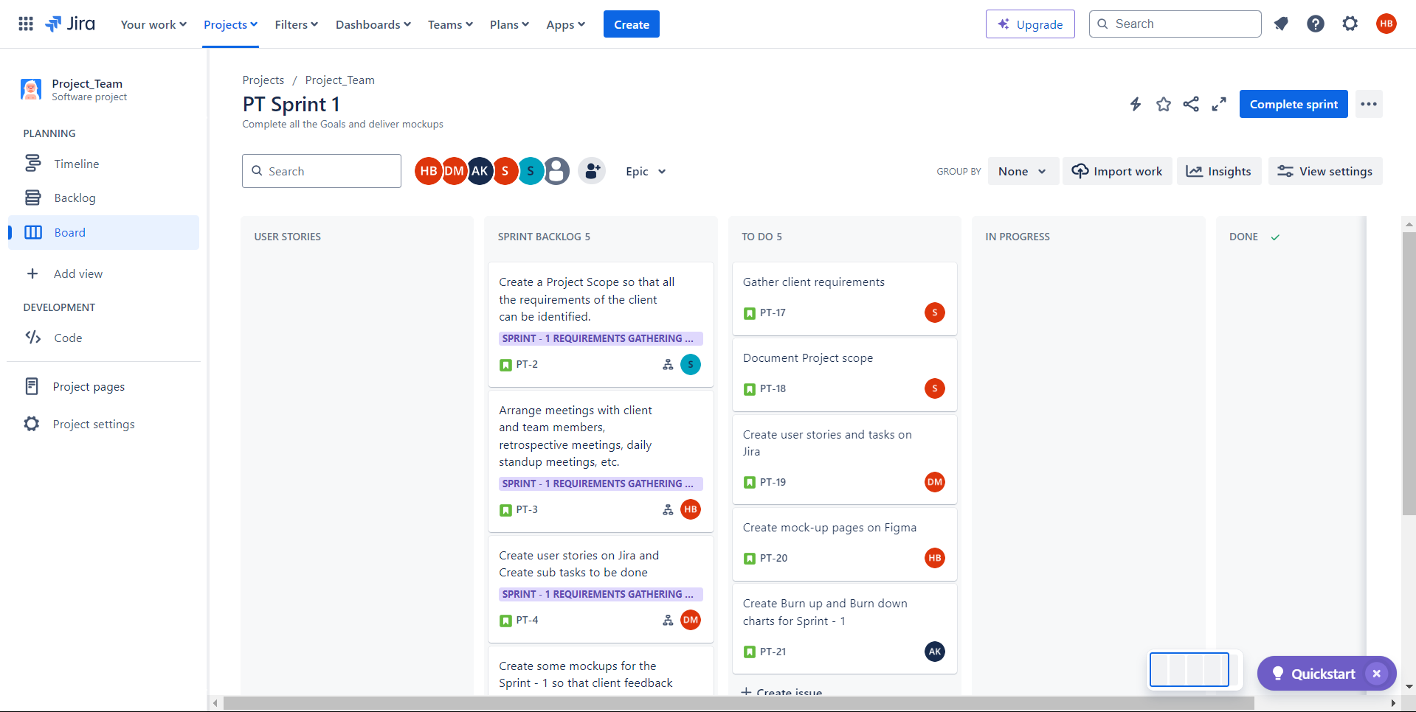Figure 8. Sprint 1 Product backlog To-Do User Stories

Figure 9. Sprint 1 Timeline

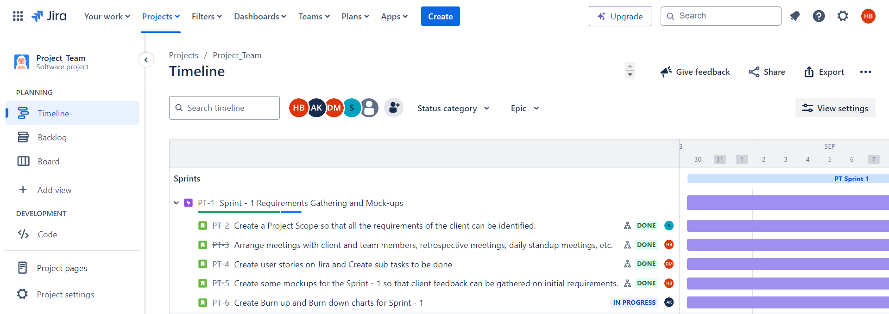

Figure 10. Completion of Sprint 1

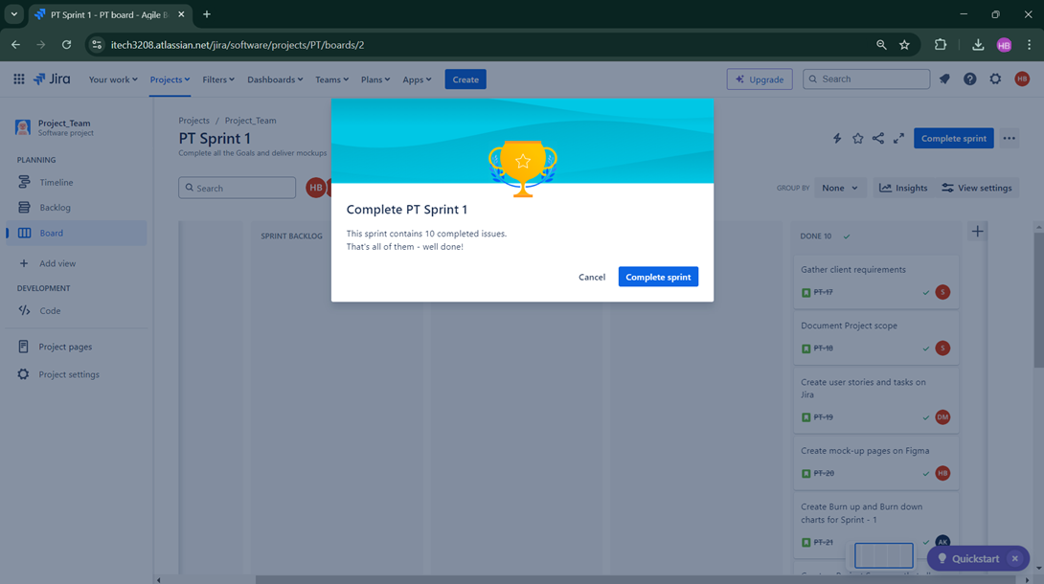

Figure 11. Documenting Sprint 2 Backlog

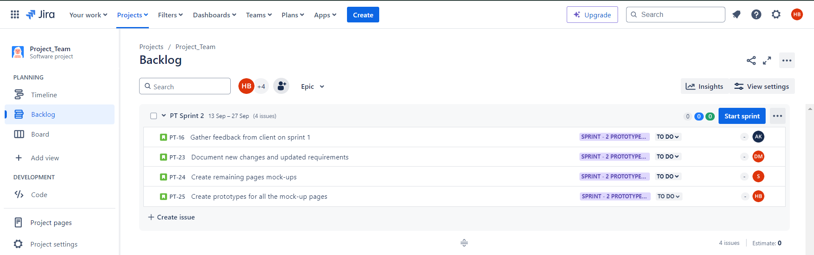

Figure 12. Moving Sprint 2 Backlog to Sprint

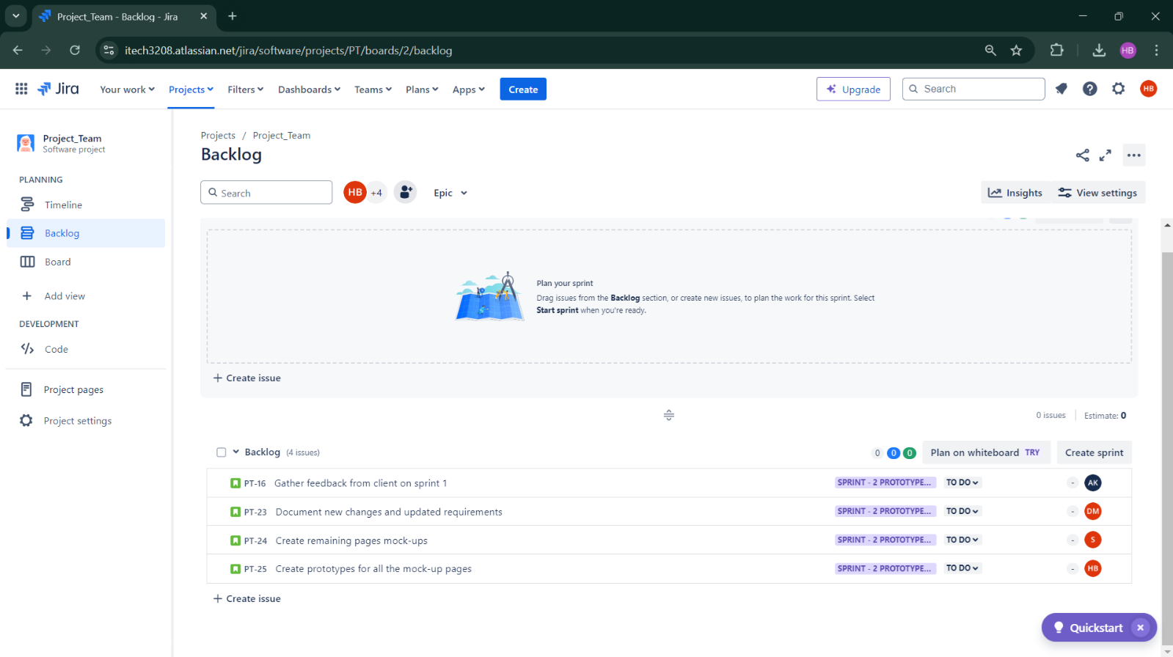

Figure 13. Jira Board for Sprint 2 with all the user stories

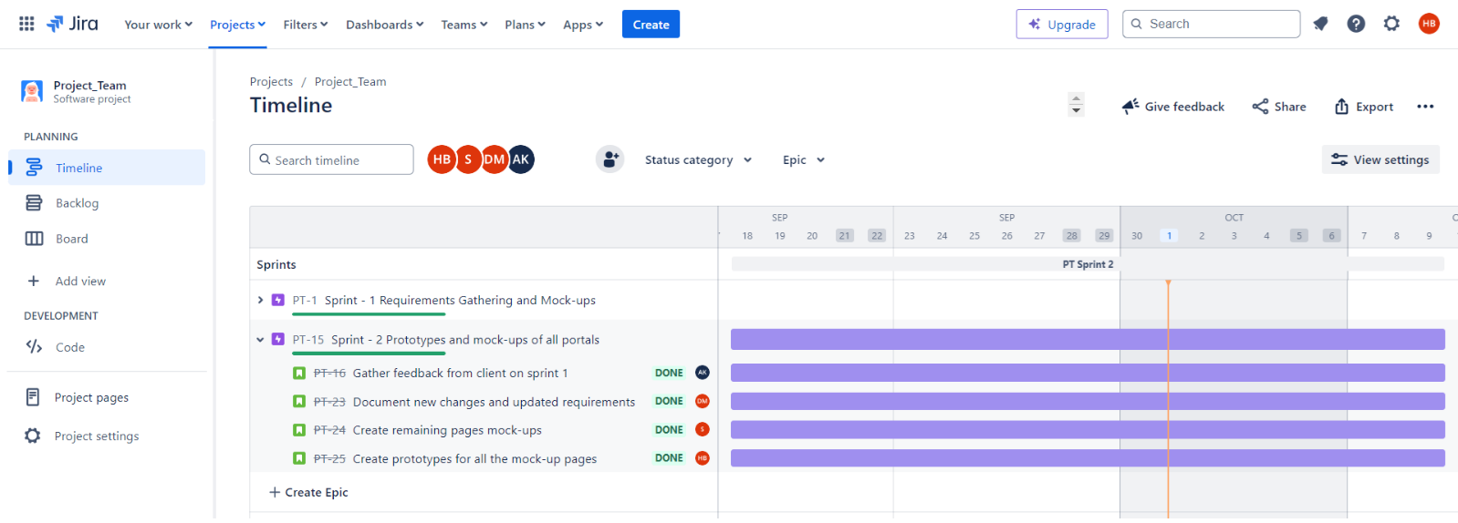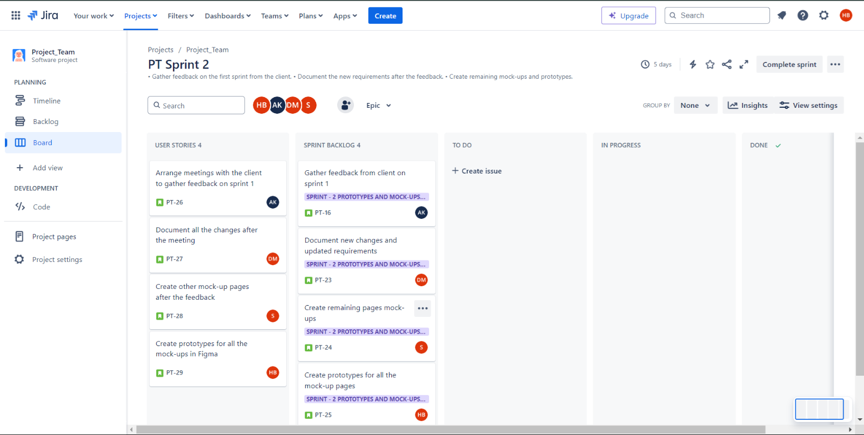

Figure 14. Sprint 2 Timeline

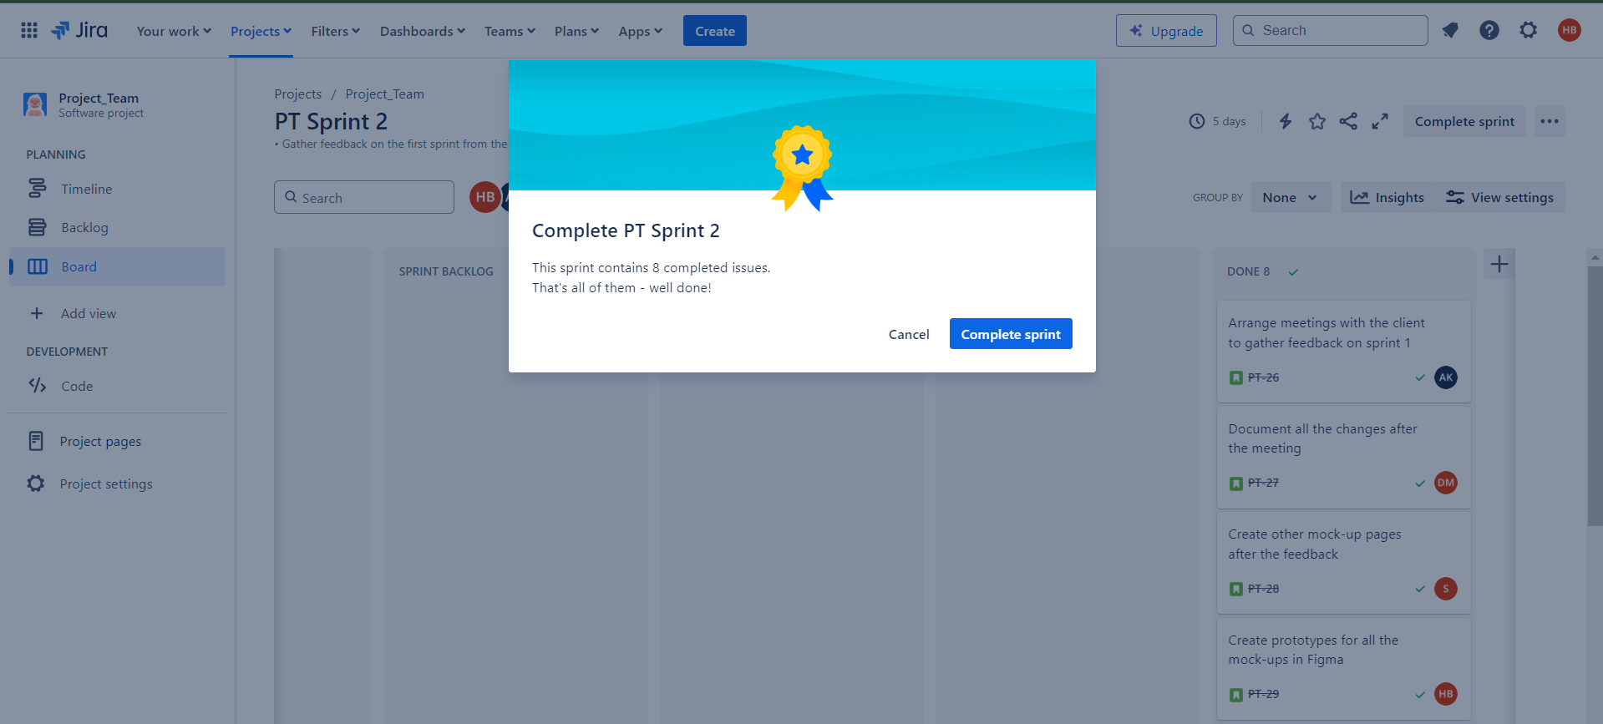

Figure 15. Sprint 2 Completion

1. Mock-ups screenshots (three completed during sprint 1 and remaining in sprint 2).

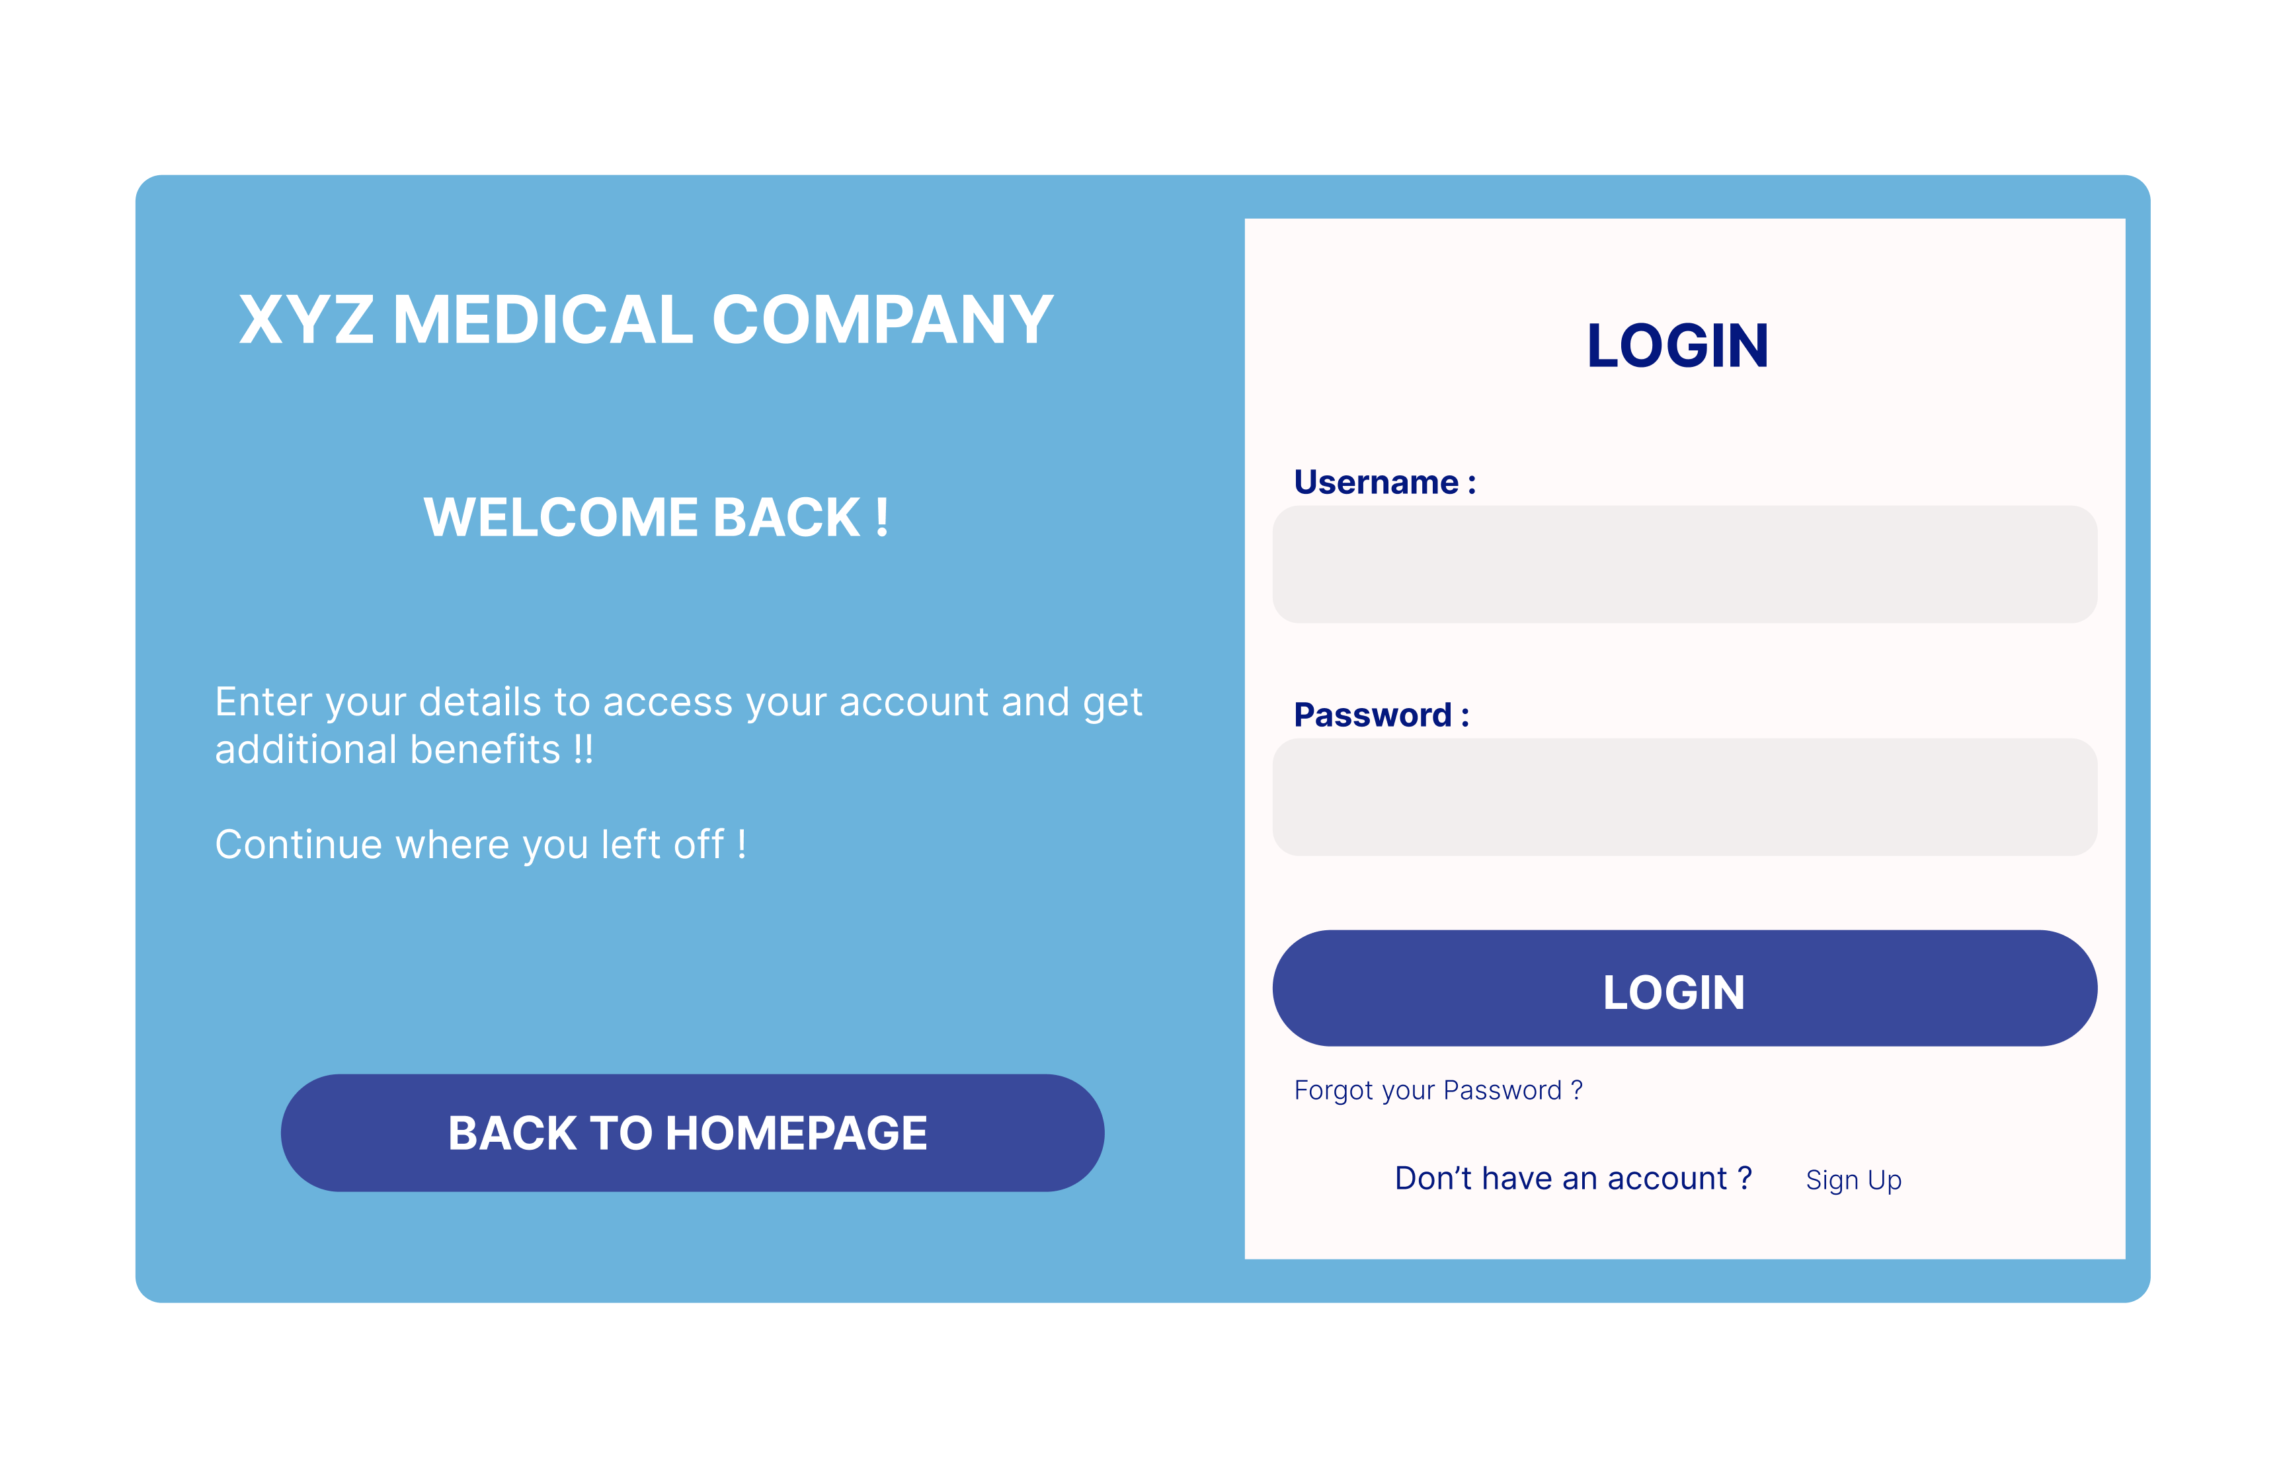

Figure 16. Login Mock-up

Figure 17. Home Page Mock-up

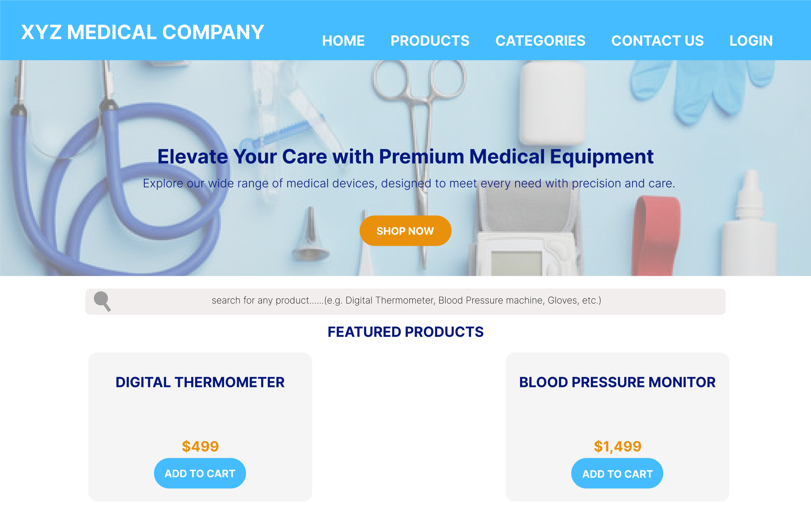

Figure 18. Products Page Mock-up

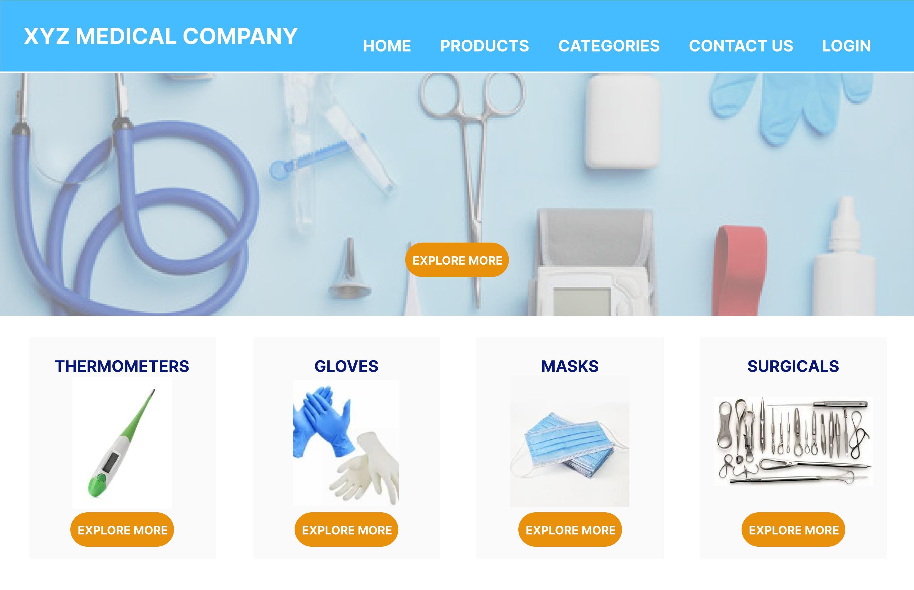

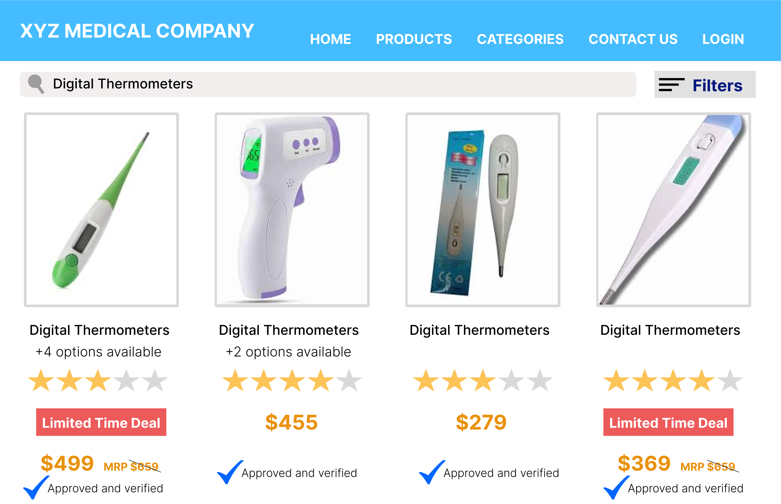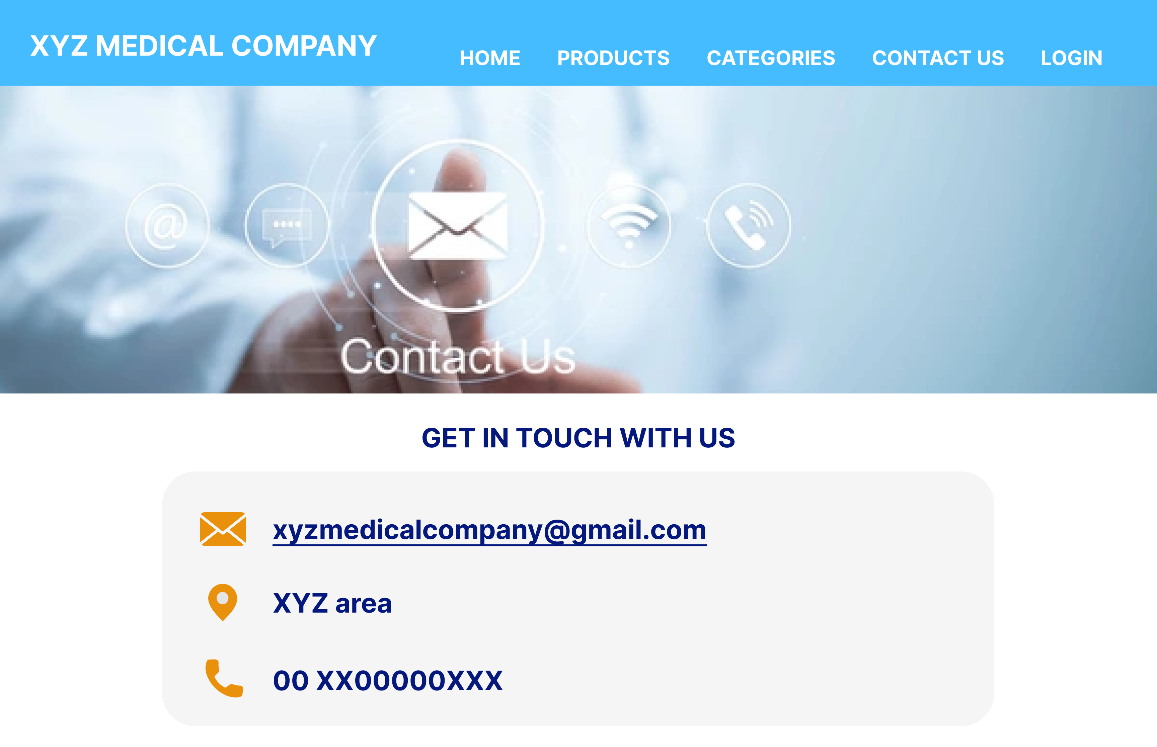Figure 19. Categories Page Mock-up

Figure 20. Contact Page Mock-up



1. Prototype screenshot (clickable prototype to be demonstrated in the walkthrough video).

This is a screenshot of the demonstrated prototype (shows the arrows and the direction of flow). While we are adding a screenshot of the prototype, a live clickable with the required flow will be demonstrated in a walkthrough video.

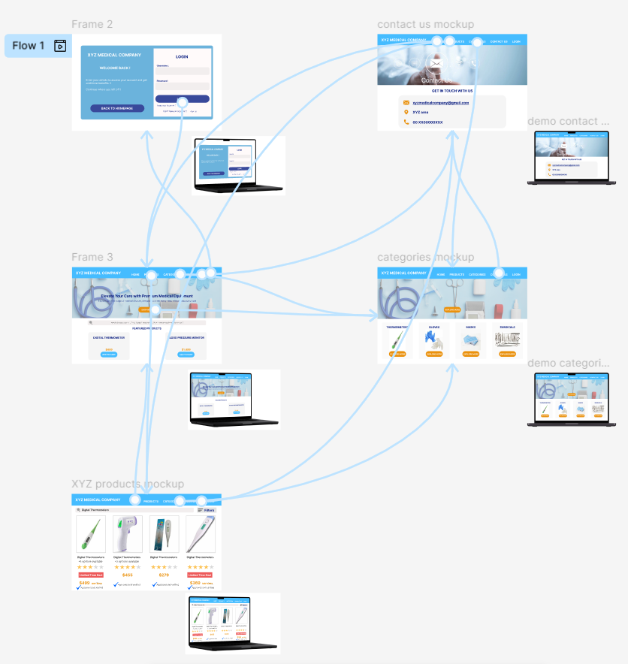Figure 21. Prototype